Ejercicio clase 9 GTICS - 20191450

## **Consumo API REST para listar personajes**

|  |  |
| --- | --- |
| **URL** | **Method** |
| http://localhost:8080/ws/personaje/list | GET |

1. **Argumentos de entrada:**

Ninguno

1. **Argumentos de salida:**

|  |
| --- |
| [      {          "id": 1026,          "name": "Absalom (Earth-616)",          "url": "/Absalom_(Earth-616)",          "identity": "Secret Identity",          "align": null,          "eye": "Blue Eyes",          "hair": "Blond Hair",          "sex": "Male Characters",          "gsm": null,          "alive": "Deceased Characters",          "appearances": 6,          "first_appearance": "May-92",          "year": 1992      },      {          "id": 1027,          "name": "Carl Creel (Earth-616)",          "url": "/Carl_Creel_(Earth-616)",          "identity": "Public Identity",          "align": "Bad Characters",          "eye": "Blue Eyes",          "hair": "Bald",          "sex": "Male Characters",          "gsm": null,          "alive": "Living Characters",          "appearances": 202,          "first_appearance": "Apr-64",          "year": 1964      },      {          "id": 1029,          "name": "Adam Warlock (Earth-616)",          "url": "/Adam_Warlock_(Earth-616)",          "identity": "No Dual Identity",          "align": "Good Characters",          "eye": "White Eyes",          "hair": "Gold Hair",          "sex": "Male Characters",          "gsm": null,          "alive": "Living Characters",          "appearances": 252,          "first_appearance": "Sep-67",          "year": 1967      },      {          "id": 1030,          "name": "Adam Neramani (Earth-616)",          "url": "/Adam_Neramani_(Earth-616)",          "identity": "Secret Identity",          "align": "Good Characters",          "eye": "Blue Eyes",          "hair": "Blond Hair",          "sex": "Male Characters",          "gsm": null,          "alive": "Living Characters",          "appearances": 21,          "first_appearance": "Oct-93",          "year": 1993      },      {          "id": 1032,          "name": "Eric Cameron (Earth-616)",          "url": "/Eric_Cameron_(Earth-616)",          "identity": "Secret Identity",          "align": "Bad Characters",          "eye": "Blue Eyes",          "hair": "Brown Hair",          "sex": "Male Characters",          "gsm": null,          "alive": "Living Characters",          "appearances": 5,          "first_appearance": "Mar-80",          "year": 1980      },  ...  ] |

* **Datos:**

|  |  |  |
| --- | --- | --- |
| **Campo** | **Tipo de Dato** | **Observaciones** |
| id | entero | - |
| name | cadena | - |
| url | cadena | - |
| identity | cadena | - |
| align | cadena | - |
| eye | cadena | - |
| hair | cadena | - |
| sex | cadena | - |
| gsm | cadena | - |
| alive | cadena | - |
| appearances | entero | - |
| first_appearance | cadena | - |
| year | entero | - |

**Ejemplo:**

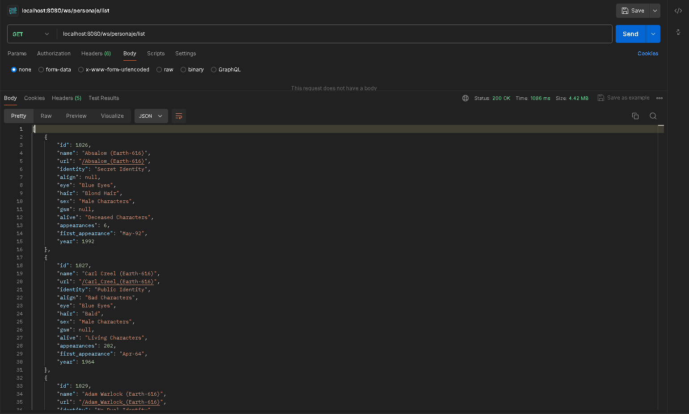

## **Consumo API REST para obtener personaje**

|  |  |
| --- | --- |
| **URL** | **Method** |
| http://localhost:8080/ws/personaje/{id} | GET |

### Argumentos de entrada:

|  |  |  |
| --- | --- | --- |
| **Campo** | **Tipo de Dato** | **Observaciones** |
| id | entero | - |

### Argumentos de salida:

**Opción 1:** Solicitud correcta

* **Http Status:** HTTP 200 OK
* **Body**:

|  |
| --- |
| * { * "result": "sucess", * "personaje": { * "id": 1025, * "name": "Emil Blonsky (Earth-616)", * "url": "/Emil_Blonsky_(Earth-616)", * "identity": "Secret Identity", * "align": "Bad Characters", * "eye": "Blue Eyes", * "hair": "Blond Hair", * "sex": "Male Characters", * "gsm": "", * "alive": "Living Characters", * "appearances": 115, * "first_appearance": "Apr-67", * "year": 1967 * } * } |

**Opción 2:** Error al ingresar un parámetro que no sea entero

* **Http Status:** HTTP 400 Bad Request
* **Body**:

|  |
| --- |
| * { * "date": "2024-05-25T16:12:57.5598748", * "error": "ID Personaje NO encontrado." * } |

**Opción 3:** El ID que se busca es menor a 0 o no esta dentro de la lista de ID’s existentes

* **Http Status:** HTTP 400 NOT FOUND
* **Body**:

|  |
| --- |
| * { * "date": "2024-05-25T16:12:57.5598748", * "error": "ID Personaje NO encontrado." * } |

### Datos argumentos de salida

|  |  |  |
| --- | --- | --- |
| **Campo** | **Tipo de Dato** | **Observaciones** |
| id | entero | - |
| name | cadena | - |
| url | cadena | - |
| identity | cadena | - |
| align | cadena | - |
| eye | cadena | - |
| hair | cadena | - |
| sex | cadena | - |
| gsm | cadena | - |
| alive | cadena | - |
| appearances | entero | - |
| first_appearance | cadena | - |
| year | entero | - |

### Ejemplos

**Solicitud correcta:**

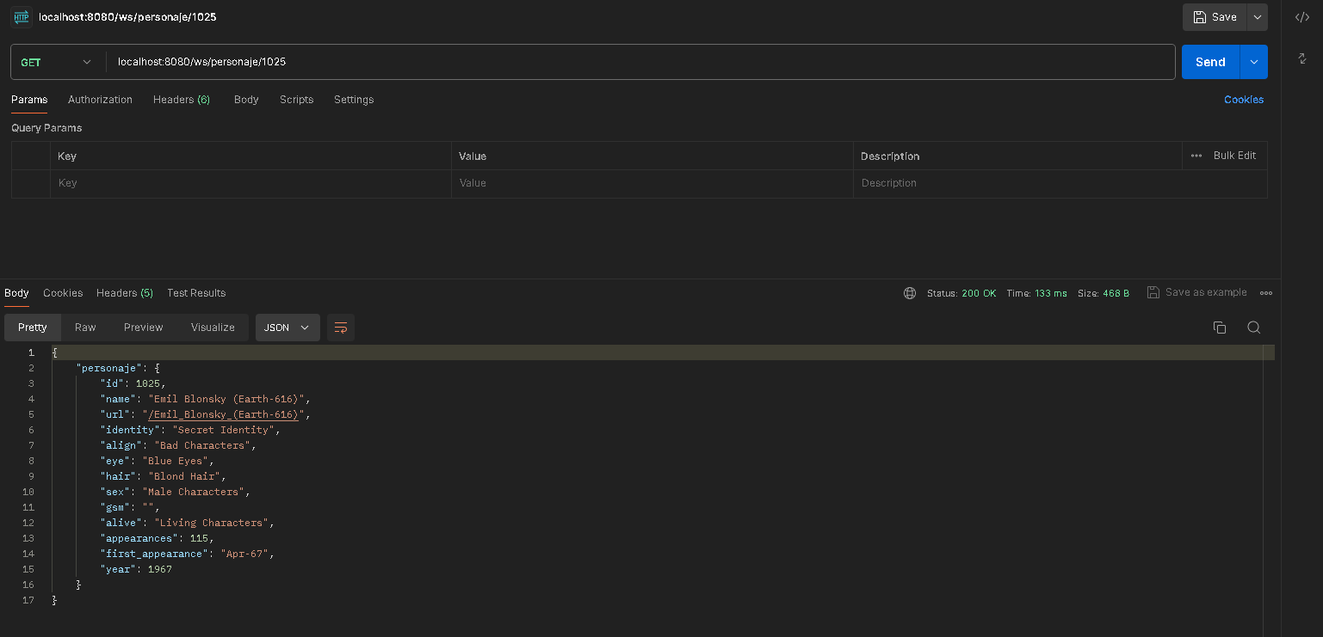

**Solicitud incorrecta:**

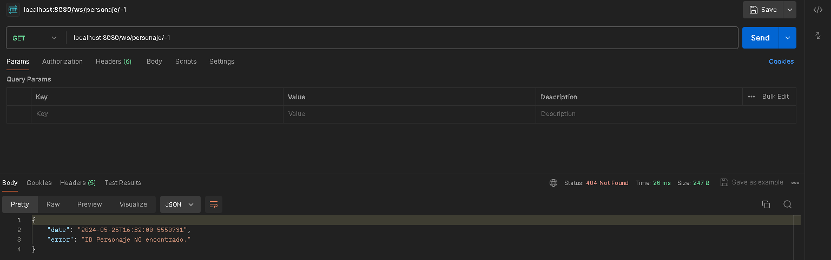

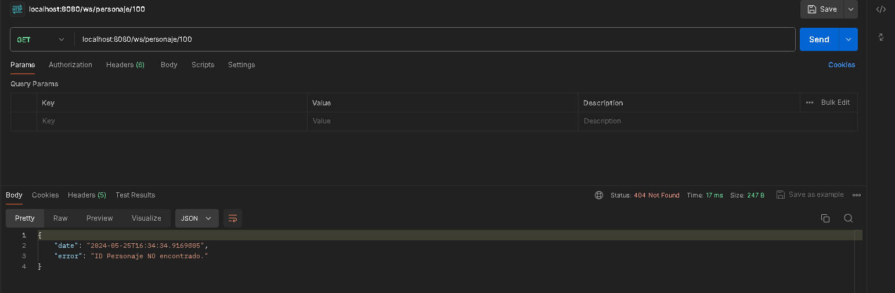

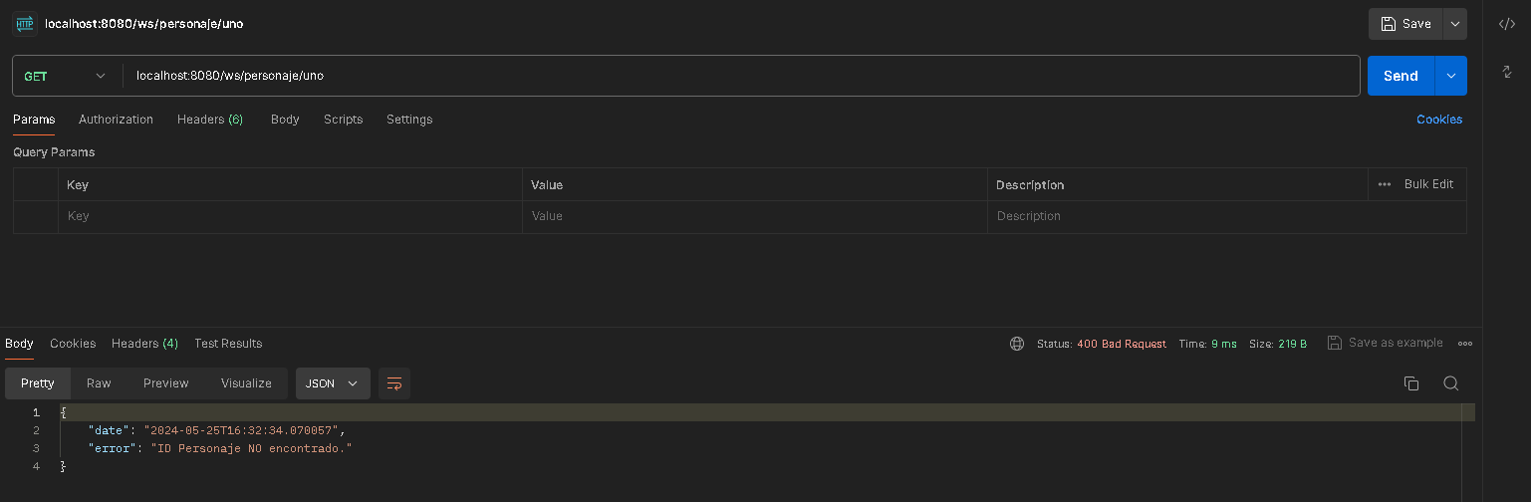

## **Consumo API REST para crear o actualizar un personaje**

|  |  |
| --- | --- |
| **URL** | **Method** |
| http://localhost:8080/ws/personaje/save | POST |
| http://localhost:8080/ws/personaje/save | PUT |

### Argumentos de entrada:

**Opción 1:** Metodo POST

* **Body**:

|  |
| --- |
| * { * "name": "Prueba Personaje", * "url": "/Prueba_Personaje", * "identity": "Secret Identity", * "align": "Bad Characters", * "eye": "Blue Eyes", * "hair": "Blond Hair", * "sex": "Male Characters", * "appearances": 115, * "firstAppearance": "Jun-2019", * "year": 2019 * } |

**Opción 2:** Metodo PUT

* **Body**:

|  |
| --- |
| * { * "id": 1025, * "name": "Emil Blonsky (Earth-616)", * "url": "/Emil_Blonsky_(Earth-616)", * "identity": "Secret Identity", * "align": "Bad Characters", * "eye": "Blue Eyes", * "hair": "Blond Hair", * "sex": "Male Characters", * "gsm": "", * "alive": "Living Characters", * "appearances": 115, * "firstAppearance": "Apr-67", * "year": 1967 * } |

### Datos de argumentos de entrada:

|  |  |  |
| --- | --- | --- |
| **Campo** | **Tipo de Dato** | **Observaciones** |
| id | entero | - |
| name | cadena | - |
| url | cadena | - |
| identity | cadena | - |
| align | cadena | - |
| eye | cadena | - |
| hair | cadena | - |
| sex | cadena | - |
| gsm | cadena | - |
| alive | cadena | - |
| appearances | entero | - |
| first_appearance | cadena | - |
| year | entero | - |

### Argumentos de salida:

**Opción 1:** Solicitud correcta – Metodo POST

* **Http Status:** HTTP 201 Created
* **Body**:

|  |
| --- |
| * { * "personaje creado": { * "id": 755287, * "name": "Prueba Personaje", * "url": "/Prueba_Personaje", * "identity": "Secret Identity", * "align": "Bad Characters", * "eye": "Blue Eyes", * "hair": "Blond Hair", * "sex": "Male Characters", * "gsm": null, * "alive": null, * "appearances": 115, * "first_appearance": null, * "year": 2019 * } * } |

**Opción 2:** Solicitud correcta – Metodo PUT

* **Http Status:** HTTP 201 Created
* **Body**:

|  |
| --- |
| * { * "personaje creado": { * "id": 755287, * "name": "Prueba Personaje", * "url": "/Prueba_Personaje", * "identity": "Secret Identity", * "align": "Bad Characters", * "eye": "Blue Eyes", * "hair": "Blond Hair", * "sex": "Male Characters", * "gsm": null, * "alive": null, * "appearances": 115, * "first_appearance": null, * "year": 2019 * } * } |

**Opción 3:** Error – Metodo POST y PUT

* **Http Status:** HTTP 400 Bad Request
* **Body**:

|  |
| --- |
| * { * "date": "2024-05-25T17:42:34.253733900", * "error": "Error en validación de Datos." * } |

### Datos argumentos de salida

|  |  |  |
| --- | --- | --- |
| **Campo** | **Tipo de Dato** | **Observaciones** |
| id | entero | - |
| name | cadena | - |
| url | cadena | - |
| identity | cadena | - |
| align | cadena | - |
| eye | cadena | - |
| hair | cadena | - |
| sex | cadena | - |
| gsm | cadena | - |
| alive | cadena | - |
| appearances | entero | - |
| first_appearance | cadena | - |
| year | entero | - |

### Ejemplos

**Solicitud correcta:**

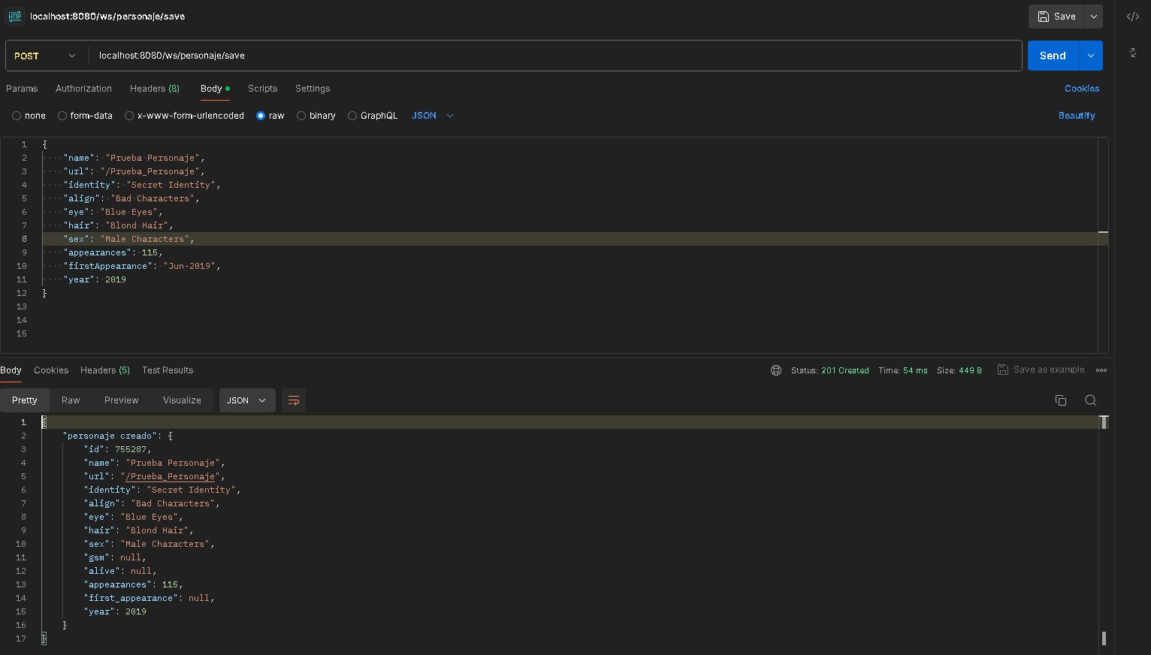

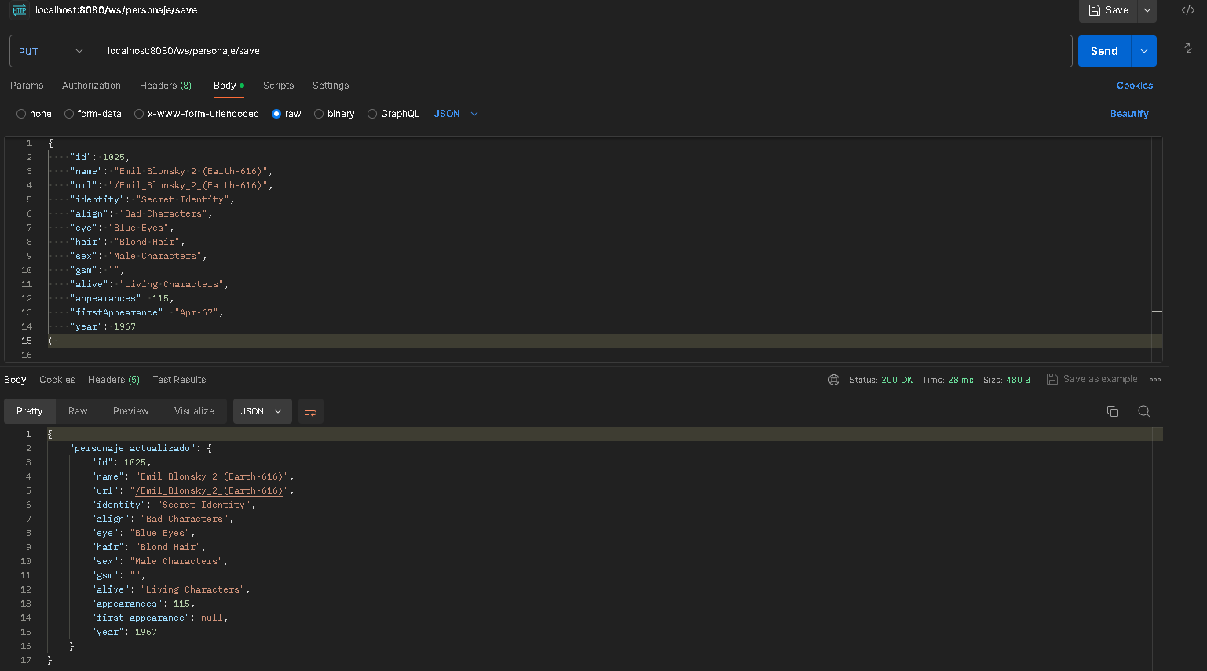

**Solicitud incorrecta:**

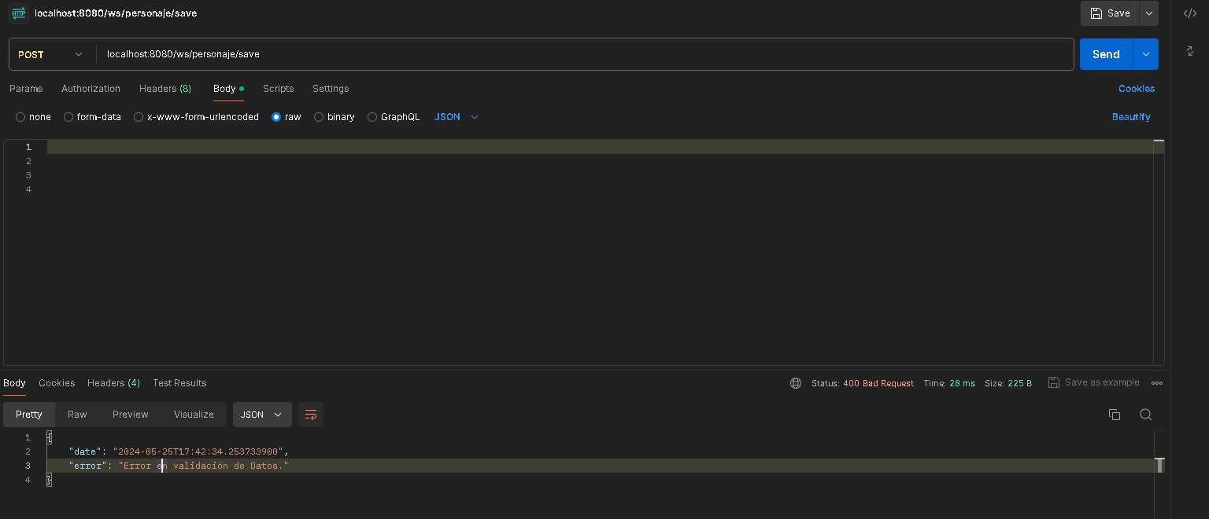

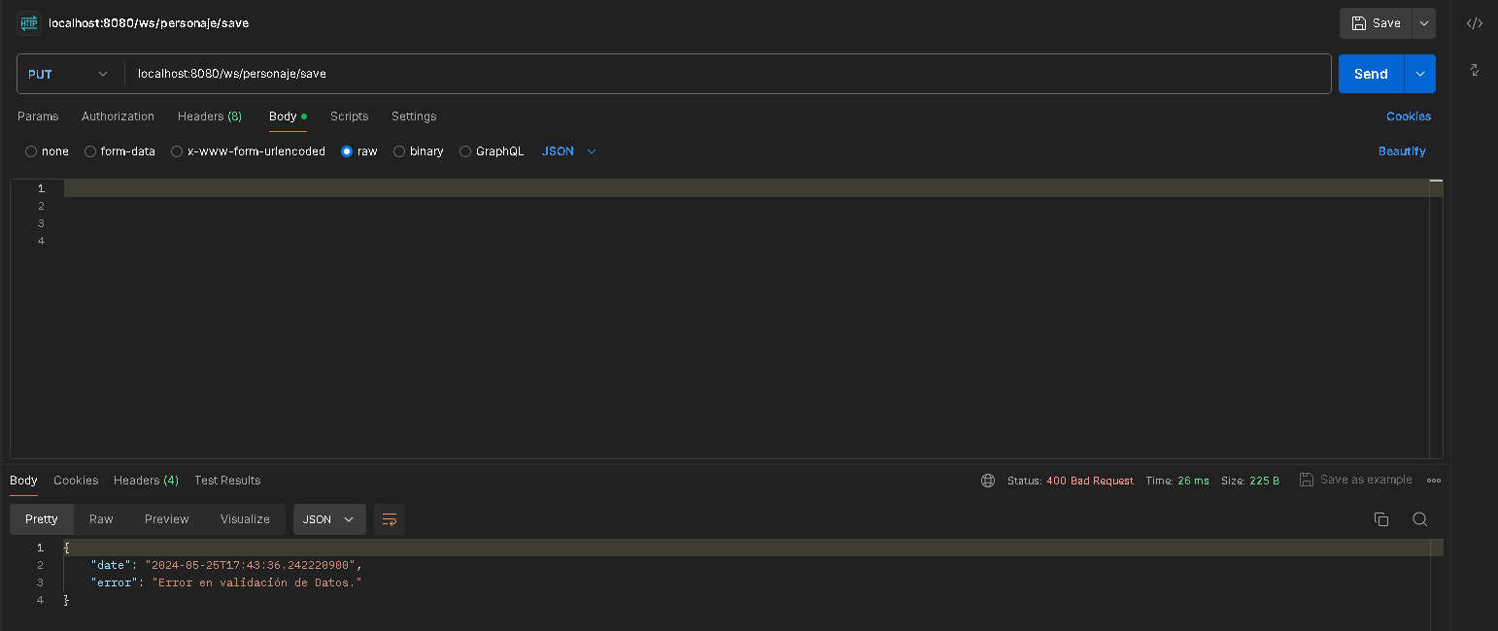

## **Consumo API REST para eliminar un personaje**

|  |  |
| --- | --- |
| **URL** | **Method** |
| http://localhost:8080/ws/personaje/delete/{id} | DELETE |

### Argumentos de entrada:

|  |  |  |
| --- | --- | --- |
| **Campo** | **Tipo de Dato** | **Observaciones** |
| id | entero | - |

### Argumentos de salida:

**Opción 1:** Solicitud correcta

* **Http Status:** HTTP 200 OK
* **Body**:

|  |
| --- |
|  |

**Opción 2:** ID ingresado no esta en la lista de ID’s existentes

* **Http Status:** HTTP 400 NOT FOUND
* **Body**:

|  |
| --- |
| * { * "date": "2024-05-25T16:12:57.5598748", * "error": "ID Personaje NO encontrado." * } |

### Datos argumentos de salida

|  |  |  |
| --- | --- | --- |
| **Campo** | **Tipo de Dato** | **Observaciones** |
| id | entero | - |
| name | cadena | - |
| url | cadena | - |
| identity | cadena | - |
| align | cadena | - |
| eye | cadena | - |
| hair | cadena | - |
| sex | cadena | - |
| gsm | cadena | - |
| alive | cadena | - |
| appearances | entero | - |
| first_appearance | cadena | - |
| year | entero | - |

### Ejemplos

**Solicitud correcta:**

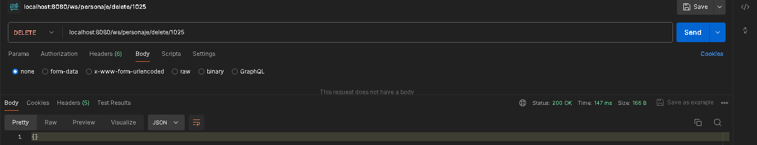

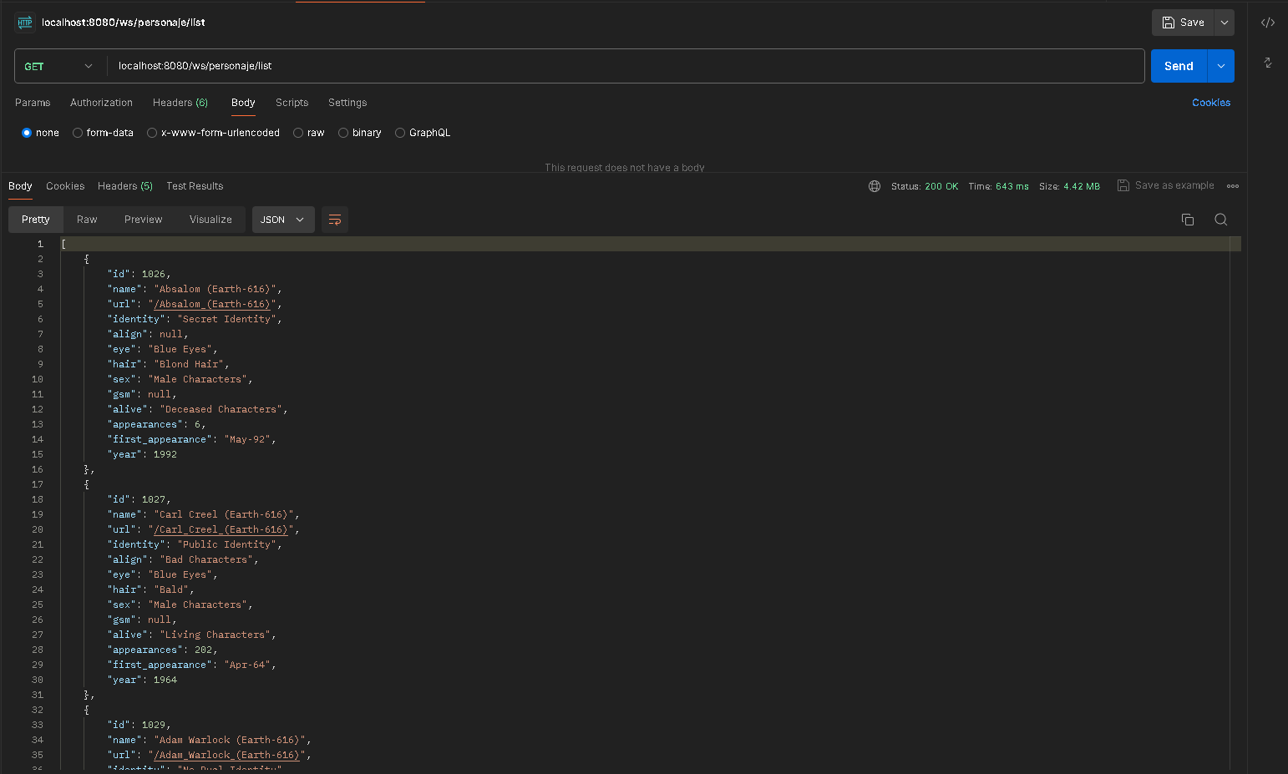

**Solicitud incorrecta:**

